Supplementary results

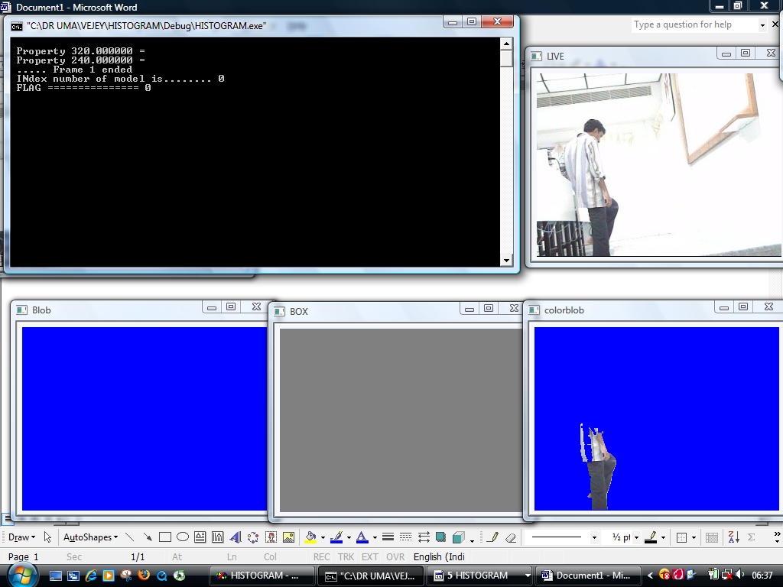

Snapshot showing the blob not acquired correctly from the background subtraction module. This is due to the same nature of colour of his shirt with that of the background.

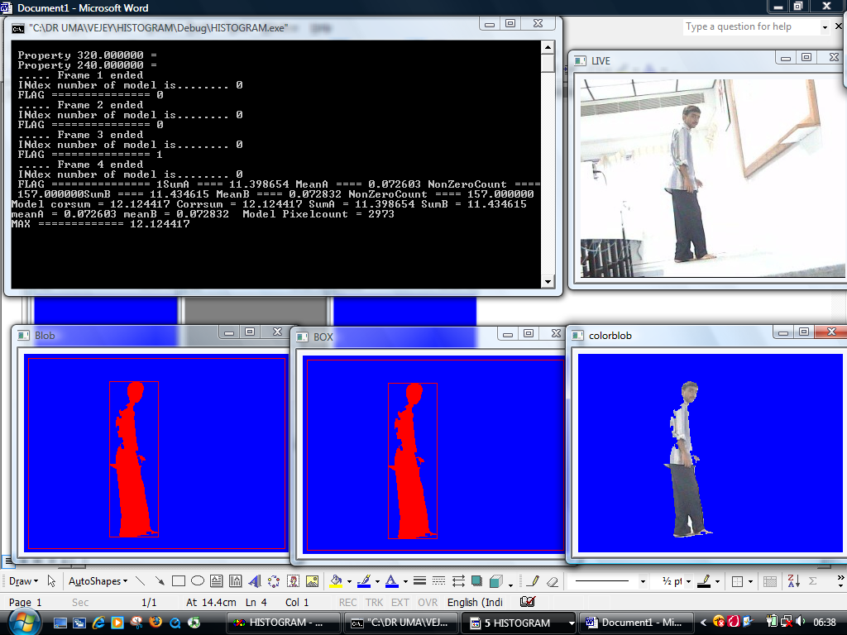
This shows the red coloring of the blob stating this is the first model that arrived.
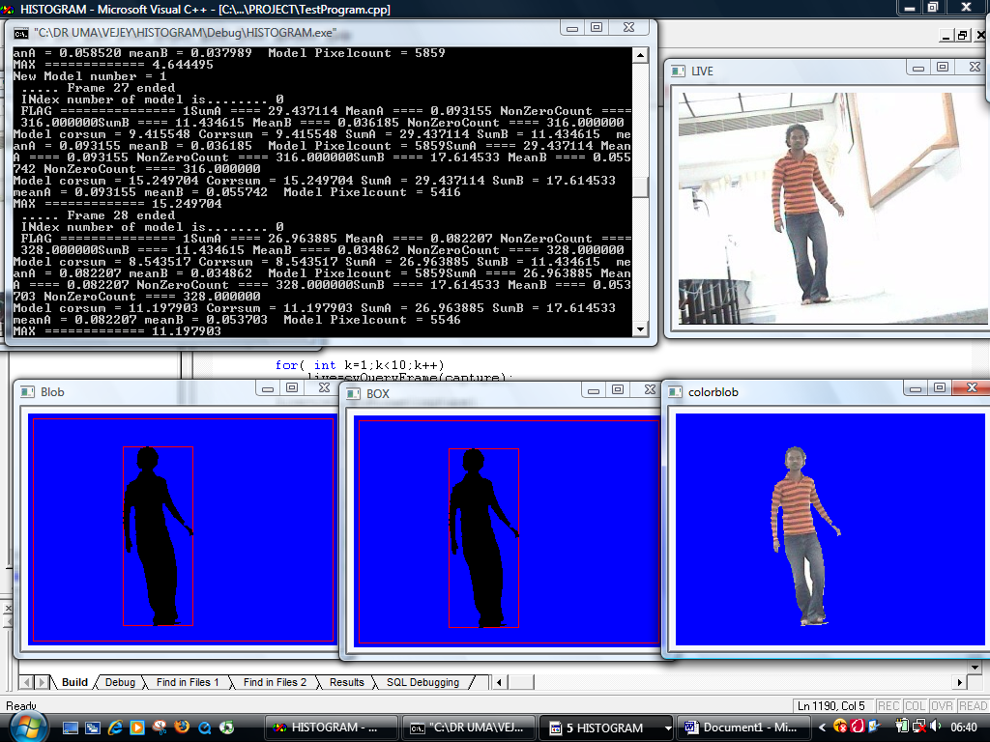
This shows the black color i.e., the second model in the list.

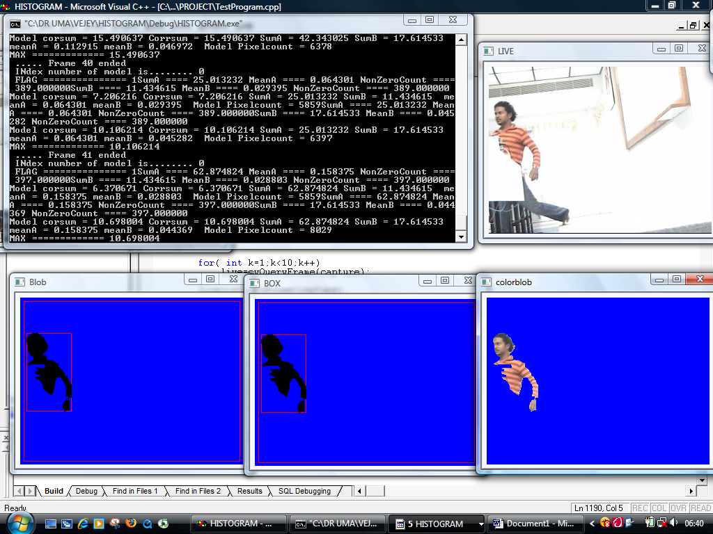
This shows the half blob on the run.
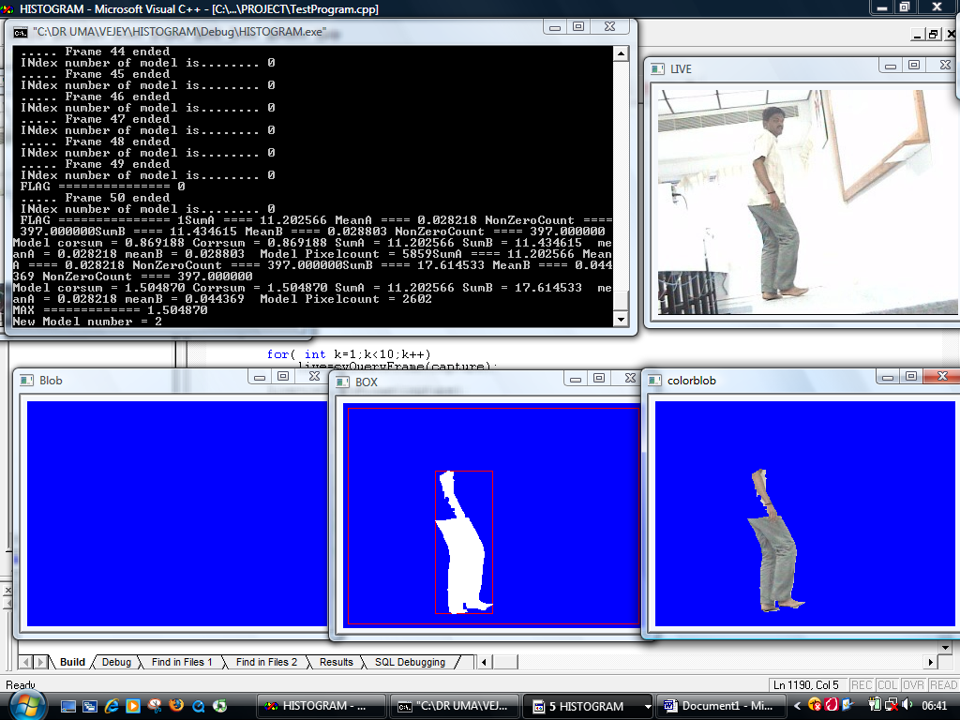
Blob is not correctly acquired because of the same coloring problem with background.
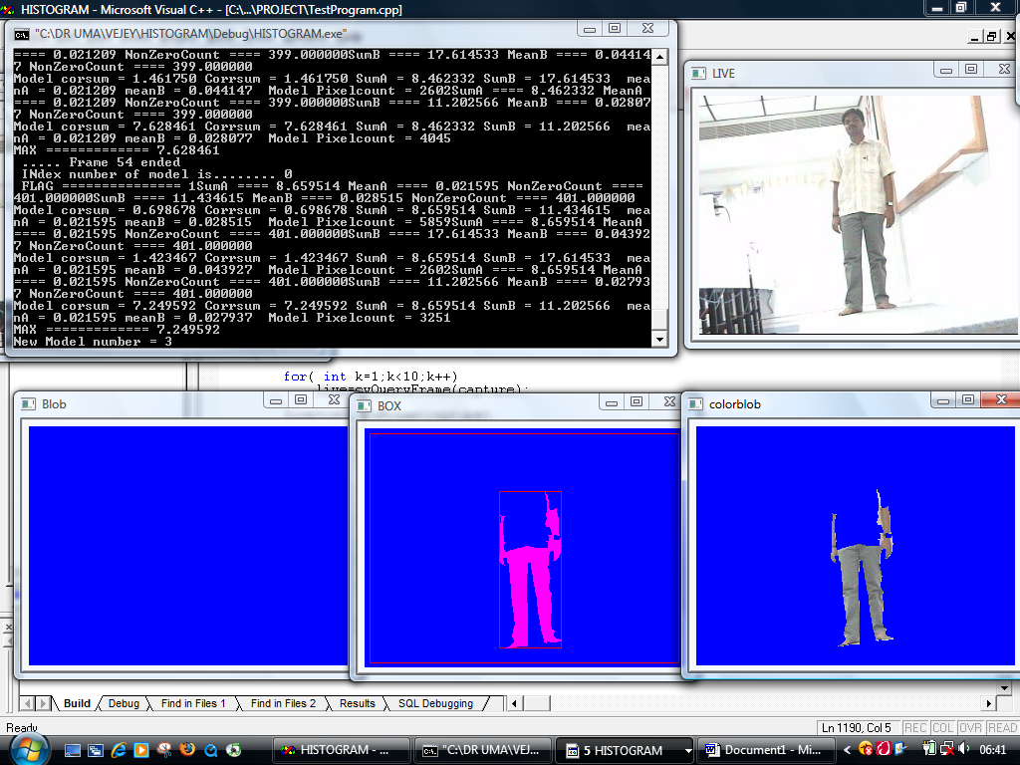
Other models are shown in this snapshot which is false positive.
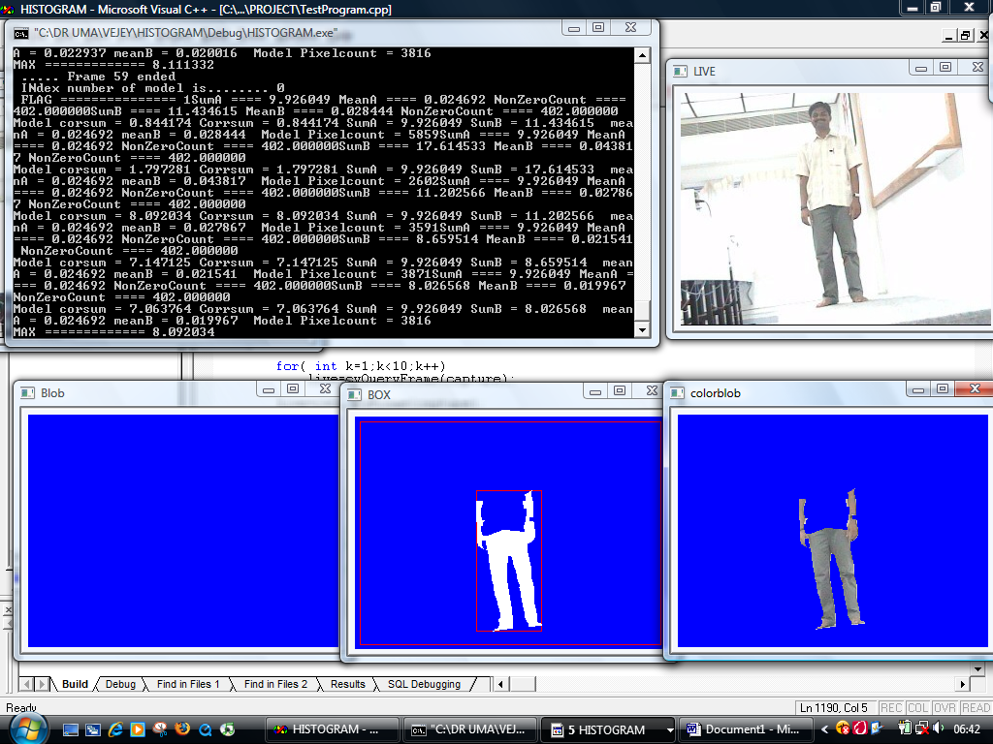

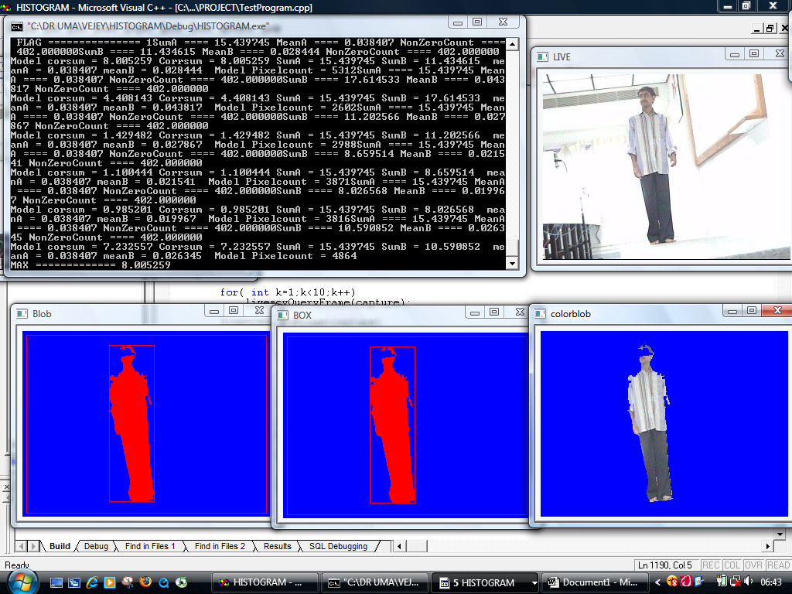
Correct identification of the red color model even when he is entering after sometime.
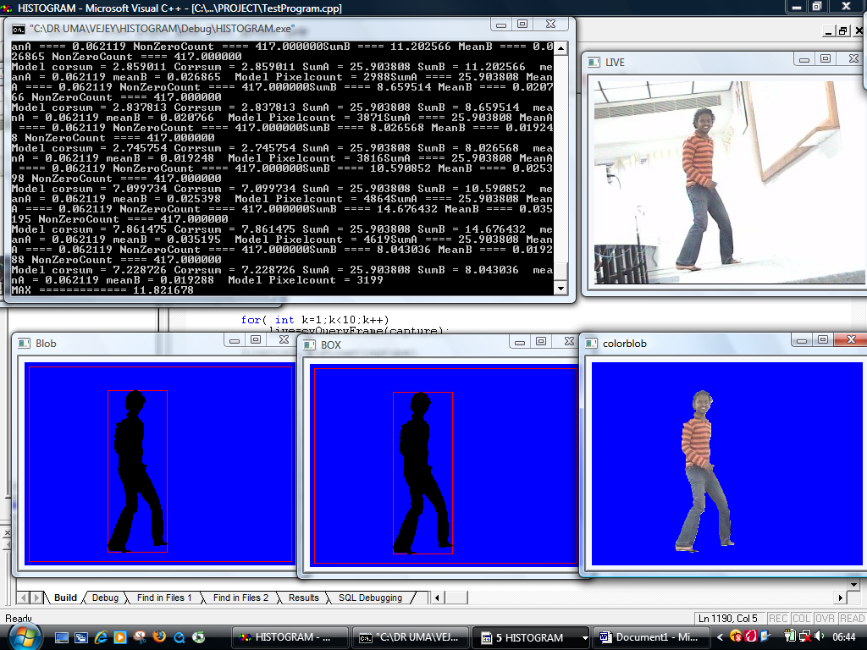
Correct identification of the black color model the second time he enters the scene.

